TECHNICAL PROPOSAL

Enhanced Technical Proposal
for Development of the NUSA Website
  - Prepared as an expanded version of the previously submitted technical proposal, with an added innovation layer covering green hosting, AI-driven engagement, Progressive Web App capabilities, and a public impact dashboard.
Project | NUSA Website Development
Proposal Type | Technical Proposal

1. Executive Summary
Naria Unnayan Samity (NUSA) is seeking a modern, accessible, bilingual, transparent, and impact-oriented website that can strengthen organizational credibility while making information, stories, publications, and engagement pathways easier to access for donors, partners, communities, and applicants.
This enhanced proposal retains the from-scratch website approach established in the original technical proposal while introducing a controlled innovation layer requested by the client. The intent is to move beyond a standard NGO website and position NUSA as a benchmark digital platform in Bangladesh's development sector.
Accordingly, the proposed solution combines a Next.js based public website, Laravel powered CMS and administration, structured bilingual publishing, and performance-focused delivery with four innovation upgrades: green hosting and digital sustainability practices, an AI-assisted public chatbot, Progressive Web App capability, and a real-time public impact dashboard.

2. Project Understanding and Strategic Objectives
The prior proposal already addressed the standard requirement set: public website sections, transparency publishing, careers, donation and get involved pathways, a lightweight partner area, mobile-first design, accessibility, SEO readiness, and secure administration. This version expands that foundation into a broader digital ecosystem that supports discoverability, stakeholder trust, ongoing engagement, and measurable visibility of impact.
• Build a new bilingual and impact-oriented website from scratch with strong content governance and manageable long-term administration.
• Improve donor and partner confidence through better transparency, clearer reporting access, and a public-facing representation of organizational reach and outcomes.
• Improve citizen and beneficiary accessibility through mobile-first delivery, low-bandwidth optimization, accessibility alignment, and optional app-like usage via PWA.
• Introduce innovation features that are relevant to development-sector use cases rather than purely commercial add-ons.
• Create a platform that can evolve over time without forcing an expensive enterprise portal in the first release.

3. Proposal Enhancement Beyond the Standard Requirement
The client has requested additional innovative solutions beyond the standard requirement baseline. Our recommendation is to incorporate these as an integrated innovation layer rather than as disconnected features. This creates a more coherent digital ecosystem and ensures that infrastructure, content, analytics, and public engagement work together.
Innovation Item | Recommended Approach | Value to NUSA | Delivery Position
Green Hosting | Use green-ready hosting with CDN, caching, image optimization, backups, and sustainability-aware delivery. | Improves responsible digital positioning and lowers delivery footprint. | Infrastructure recommendation
AI-driven User Engagement Tools | Deploy a public chatbot trained on approved website content, FAQs, contact details, and escalation rules. | Improves self-service discovery and stakeholder support. | Controlled public support module
Progressive Web App | Enable installability, shell caching, offline fallback, and quick-return mobile access. | Improves usability in low-connectivity and mobile-first contexts. | Feature enhancement
Real-time Public Impact Dashboard | Publish approved KPI, geography, reach, and update-ready metrics in a visual dashboard. | Improves transparency, visibility, and donor confidence. | Transparency enhancement

4. Innovation Layer - Recommended Solution Design

4.1 Green Hosting and Digital Sustainability
International practice is increasingly moving toward digital sustainability, where website delivery is not only secure and fast but also energy-conscious. For NUSA, this does not require a specialized experimental stack. Instead, we recommend choosing a renewable-energy-backed or green-verified hosting provider, fronting the platform with a CDN, and optimizing the website for lower transfer size, longer cache reuse, compressed media, and efficient page generation.
• Deploy on a green-ready hosting environment where possible, supported by verification-friendly hosting evidence and sustainability reporting readiness.
• Use server-side caching, CDN acceleration, image compression, lazy loading, and modern asset pipelines to reduce transfer size and energy intensity.
• Use optimized fonts, responsive image delivery, and page weight governance as part of routine content publishing standards.
• Maintain backup retention, update governance, and monitoring so sustainability does not compromise resilience.

4.2 AI-driven User Engagement Tool (Public Website Chatbot)
A public-facing chatbot can improve user engagement when implemented with clear scope and governance. For NUSA, the chatbot should be positioned as a knowledge and navigation assistant rather than an unsupervised decision-making tool. It will answer common questions from approved public content, help users find programs, reports, events, publications, and contact paths, and escalate to human channels when a request falls outside the approved knowledge base.
• Knowledge source restricted to approved public content and curated FAQ material.
• Bilingual prompt and response support for English and Bangla, depending on approved content readiness.
• Safe-answer and escalation rules for sensitive, uncertain, or policy-related questions.

4.3 Progressive Web App Capability
Because many users in Bangladesh access NGO and development-sector websites primarily from mobile devices and variable network conditions, PWA capability is a high-value enhancement. A PWA does not replace the website. Instead, it extends the website so users can install it to their home screen, load faster on repeat visits, and retain limited offline continuity for selected content and shell assets.
• Installable experience through a web app manifest.
• Service worker-based caching for the application shell and selected key pages.
• Offline fallback messaging and graceful degraded behavior where live data is unavailable.

4.4 Real-time Public Impact Dashboard
Development organizations increasingly benefit from structured public dashboards that present selected indicators in a more transparent and understandable way than static PDF-only reporting. For NUSA, the recommended dashboard is not a complex BI replacement. It is a curated public reporting layer that displays approved metrics such as project coverage, thematic areas, beneficiary reach, training counts, publication activity, or campaign updates through charts, counters, maps, and filterable views.
• Public dashboard fed from admin-controlled datasets or structured imports, not unrestricted live operational systems.
• Dashboard KPIs defined during discovery so only meaningful and governance-approved indicators are shown.
• Geographic and thematic filtering to help donors, partners, and visitors understand reach and impact quickly.
• Export-ready and presentation-friendly views for donor communication.

5. Proposed Technical Approach

5.1 Solution Architecture
To satisfy the requirement for a scalable and maintainable solution while keeping the implementation practical, we propose headless-style architecture. The public website will be built with a React-based frontend for performance and SEO-friendly rendering, while Laravel will provide the backend CMS, API layer, admin authentication, media handling, and content workflows. This approach is compatible with the ToR direction for either headless CMS or highly optimized website architecture and is well-suited for a new build from scratch.
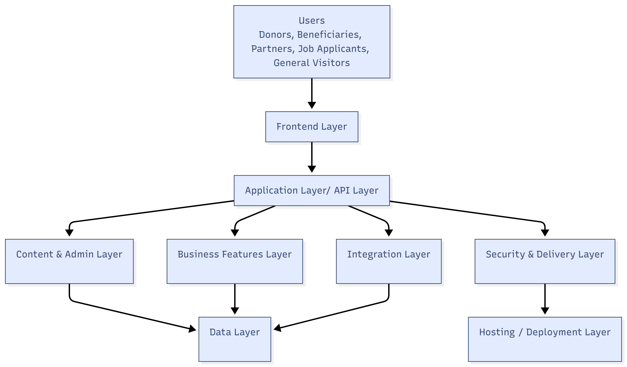

5.2 Content, UX, and Accessibility Approach
The platform will be designed for low-friction public use. Content architecture will prioritize donors, partners, beneficiaries, researchers, job applicants, and general visitors. The website will be bilingual, mobile-first, and aligned with current accessibility expectations. We recommend targeting WCAG 2.2 Level AA aligned implementation, so the platform remains consistent with current web accessibility practice.
• Discovery-led information architecture with clear content grouping and reduced navigation friction.
• Unicode-safe bilingual content structure for Bangla and English.
• Accessibility-oriented layouts including keyboard usability, semantic markup, alt text discipline, contrast compliance, and visible focus treatment.
• Low-bandwidth optimization through image sizing, lite rendering strategy, and reduced page bloat.

5.3 Public Data and Transparency Architecture
The dashboard and transparency-related areas should share structured content models so NUSA does not manage reporting in scattered formats. Governance-related documents, annual reports, audit statements, policies, project datasets, and impact stories should be published in reusable structures that support both browsing and future analytics.
• Structured repository for reports, policies, notices, and stories.
• Reusable data model for impact indicators and dashboard updates.
• Metadata fields to support filtering, search, discoverability, and future API-based reuse.
• Admin validation workflows to reduce publication errors.

6. Proposed Technical Stack
Layer | Recommended Stack | Purpose
Frontend | Next.js (React) | Public website rendering, SEO-friendly pages, multilingual UI, and PWA support
Backend | Laravel | CMS, admin panel, APIs, forms, authentication, and workflow logic
Database | MySQL | Structured content, forms, users, indicators, stories, and system data
Storage | Object/File Storage | Publications, reports, images, documents, media assets, and backups
Web Server | Nginx | Reverse proxy, compression, cache policy, and secure request handling
Security Layer | WAF/CDN + MFA | Traffic filtering, admin protection, caching, and delivery acceleration
Analytics | GA4 + consent-aware events | Traffic, content performance, donate/get involved tracking, and chatbot usage insights
Chatbot Layer | LLM-backed assistant with approved knowledge base | Public Q&A, content discovery, FAQ support, and escalation
PWA Layer | Manifest + service worker | Installability, repeat-visit acceleration, and offline fallback
Dashboard Layer | Charting + admin-managed indicator service | Public KPI display, filters, and thematic insights
Notifications | SMTP / transactional email | Form alerts, job applications, and admin acknowledgments

7. Development Methodology
We recommend a phased but tightly governed delivery approach. The original proposal structure remains valid, but the innovation items are woven into design, data modeling, and QA rather than treated as separate late-stage experiments.
• Discovery and planning: stakeholder workshops, content audit, innovation scoping, dashboard KPI definition, chatbot knowledge scope, and hosting strategy confirmation.
• UX and UI design: responsive layouts, dashboard wireframes, PWA entry states, chatbot placement strategy, and accessibility review.
• Development: public website, CMS, innovation module integration, dataset configuration, and staging deployment.
• QA and UAT: functionality, security, performance, bilingual content checks, accessibility checks, and controlled user acceptance.
• Launch and handover: production deployment, hosting hardening, analytics activation, training, user manual handover, and stabilization support.

8. Deliverables
Stage | Deliverables | Output
I. Discovery | Kick-off, scope confirmation, innovation scope validation, information architecture, KPI shortlist, hosting and security decisions | Approved inception pack
II. Design | Responsive wireframes, page designs, dashboard views, chatbot touchpoints, and accessibility considerations | Approved UI/UX set
III. Development | Next.js frontend, Laravel backend CMS/admin, bilingual structures, chatbot integration, PWA setup, dashboard module, and staging deployment | Functional beta on staging
IV. QA | Functional testing, responsive testing, accessibility review, performance review, security validation, and issue fixing | Release candidate
V. Launch | Production deployment, DNS support, caching/CDN activation, analytics setup, and go-live stabilization | Live production release
VI. Training & Handover | Admin training, concise manuals, dashboard update guidance, credentials handover, and source handover pack | Training completion and handover pack

9. Testing and Quality Assurance
The platform should be tested not only as a website, but as a public digital service. This is especially important because accessibility, public trust, and performance are central to the client's stated objectives.
QA Area | Coverage | Expected Outcome
Functional testing | Navigation, forms, CMS workflows, dashboard filters, chatbot answer flows, and bilingual rendering | All agreed modules work correctly
Responsive testing | Mobile, tablet, desktop, common browsers, and low-bandwidth interaction checks | Consistent multi-device experience
Accessibility testing | Keyboard navigation, semantic structure, contrast, focus state, and screen-reader-friendly patterns | WCAG 2.2 AA aligned target
Performance testing | Caching, asset optimization, image delivery, dashboard load behavior, and PWA repeat-visit behavior | Fast, stable, and lightweight public delivery
Security testing | Auth, MFA, role permission checks, input validation, package hardening, and backup verification | Reduced exposure to common web risks
Content validation | Publication templates, dashboard data checks, and chatbot knowledge review | Reliable public information quality



10. Proposed Implementation Timeline
We propose a 14-weeks delivery window from kick-off to final training and handover.

11. Training, Handover, and Support
• Two training sessions for content administrators and operational users.
• Concise user manuals covering page management, publication uploads, dashboard data updates, and chatbot content governance.
• Structured source code and deployment handover checklist.
• Operational guidance for backups, hosting administration, and routine update discipline.
• Support period to be aligned with contractual terms, with post-launch stabilization included immediately after go-live.

12. Assumptions and Controlled Exclusions
• Final content, translations, reports, policy documents, photos, videos, and approved KPI definitions will be provided or validated by NUSA during the project.
• Any third-party hosting plan, CDN subscription, AI service subscription, email service, payment provider, or analytics account requiring procurement will be selected or approved by NUSA.
• The chatbot is scoped as a public information assistant based on approved content, not as a case-management or beneficiary decision engine.
• The dashboard is scoped as a curated transparency and impact reporting layer, not as a full enterprise BI platform.
• PWA functionality is scoped as installability, shell caching, and offline fallback. Native-app-level background features are not assumed for the initial release.

13. Conclusion
This enhanced proposal preserves the practicality of the original NUSA website solution while elevating it into a stronger digital innovation package. By combining bilingual web delivery, structured transparency publishing, green hosting practices, AI-assisted engagement, mobile-friendly PWA capability, and a public impact dashboard, NUSA can move beyond basic compliance and present itself as a digitally mature development organization.
The proposed direction is intentionally balanced: innovative enough to create sector differentiation, but controlled enough to remain implementable, maintainable, and cost-aware.

